A MAJOR-PROJECT REPORT

ON

***“ON_ROAD_ASSISTANCE”***

Submitted to

KIIT UNIVERSITY

BY

KINGSHUK SEN 1514024

RITIKA RAJ 1508128

DEBANGANA CHAKRABORTY

UNDER THE GUIDANCE OF PROF. **Aarti G Agarkhed**

SCHOOL OF COMPUTER ENGINEERING

KALINGA INSTITUTE OF INDUSTRIAL TECHNOLOGY

BHUBANESWAR, ODISHA - 751024

2018-2019

|  |  |  |  |  |  |  |
| --- | --- | --- | --- | --- | --- | --- |
| |  | | --- | | School of Electronics Engineering | | **KALINGA INSTITUTE OF INDUSTRIAL TECHNOLOGY**  (Deemed to be University)  BHUBANESWAR | |  | | APRIL 2019 | | | |
|  | | |
|  | | |
|  | | |
|  | | |
|  | | |
|  | | | |
|  | | | |
| **CERTIFICATE**  This is to certify that the project report entitled **“DESIGN OF ON_ROAD_ASSISTANCE_APPLICATION”**   |  |  | | --- | --- | | **KINGSHUK SEN**  **RITIKA RAJ**  **DEBANGANA CHAKRABORTY** | **1514024**  **1508128**  **1304160** |   in partial fulfilment of the requirements for the award of the **Degree of Bachelor of Technology** in **Electronics department and Electrical department** is a bonafide record of the work carried out under my(our) guidance and supervision at School of Electronics Engineering, KIIT (Deemed to be University). | | | |
| Signature of Supervisor 1  Prof. Arindam Deb  School of Electronics Engineering  KIIT (Deemed to be University) | Signature of Supervisor 2  XXXXXXXX  School of Electronics Engineering  KIIT (Deemed to be University) |

|  |  |
| --- | --- |
| **The Project was evaluated by us on _____________** | |
|  | |
| EXAMINER 1 | EXAMINER 2 |
| EXAMINER 3 | EXAMINER 4 |

ACKNOWLEDGEMENTS

We feel immense pleasure and feel privileged in expressing our deepest and most sincere gratitude to our supervisor **Professor Aarti G Agarkhed**, for her excellent guidance throughout our project work. Her kindness, dedication, hard work and attention to detail have been a great inspiration to us. Our heartfelt thanks to you mam for the unlimited support and patience shown to us. We would particularly like to thank her for all her help in patiently and carefully correcting all our manuscripts. We acknowledge the support received from Cognizant company, Pune.We are also very thankful to **Professor Ghanashyam Rout** B.tech project coordinator (Electronics department), Associate Dean Professor **Dr. Amlan Datta** and **Professor Dr. Arun Kumar Ray**, Dean (School Of Electronics) for their support and suggestions during our course of the project work in the final year of our undergraduate course.

**RITIKA RAJ (1508128)**

**KINGSHUK SEN (1514024)**

**DEBANGANA CHAKRABORTY (1304160)**

ABSTRACT

**Cognizant** is an American multinational corporation that provides IT services, including digital, technology, consulting, and operations services. It is headquartered in Teaneck, New Jersey,United States of America. Cognizant is included in the NASDAQ-100 and the S&P 500 indices. It is also one of the fastest growing Fortune 500 companies. It was founded as an in-house technology unit of DUN & BRADSTREEIN in 1994, and started serving external clients in 1996.

Cognizant had a period of fast growth during the 2000s, becoming a Fortune 500 company in 2011. In 2015, the FORTUNE Magazine named it as the world's fourth most admired IT Services company. In 2017, Cognizant was named in Fortune’s Future 50 list.

Cognizant provides information technology, information security, consulting, ITO and BPO services. These include business & technology consulting, system integration, application development & maintenance, IT infrastructure services, analytics, business intelligence data , warehousing, customer relationship management, supply chain management, engineering & manufacturing solutions, enterprise resource planning, research and development, outsourcing, and testing solutions.

Cognizant has three key practice areas that span its business — Digital Business, Digital Operations, and Digital Systems & Technology.

**Chapter 1**

Introduction

1. **Purpose of this Project**

This Project is aimed at:

• This Project is about the mechanic and customer login in which there would be two user using the web.

• This project is about On_Road_assistance where the customer end would login to share the problems related to him/her like tyre puncture,need of petrol,accident or some basic needs related to the vehicle.

•And the customer would send request to the local mechanics present over those arena.

•Similarly there would be mechanic end login where the mechanic would either accept or reject the request send by the customer.

This acception or rejection by the mechanic would be further notified to the customer end.

The purpose of this document is to systematically capture requirements for the project and the system to be developed. The document also captures the Functional requirements and serves as an input for the scope of project.

1.1 Objectives

Below are the objectives that shall be fulfilled post the execution of this project:

• Customer and Mechanic registration and credential authentication.

• Requests for service by customer.

• Location based searching of mechanics.

• Accepting requests made by customer and providing service.

• Customer will also provide rating to the mechanic on the basis of the service.

• Real time navigation.

1.2 Intended Audience

• Interns/Project Team

• Mentors and SME’s

**1.1.0 Business Case**

With new vehicular addition to the roads each day, the traffic density has been creeping significantly. With increasing traffic, there has also been a strong pattern of tourist spot exploration by using their personnel vehicle. This causes more dependence on roadside assistance should there be a situation of vehicular breakdown, fuel insufficiency or accident. A mobile app, which shall let the users to request for an on-road assistance will be a game changer to the automobile industry.

The solution developed will address the objective in a holistic manner and will have all the features and functionalities which shall let the portal allow a customer to perform a location based search, browse by the nature of service offered and contact info. This shall allow the mechanic to accept the request from the customer and a real time navigation can be performed. Customer rating for the service will be an added feature.

**1.1.1 Technologies Recommended**

|  |  |
| --- | --- |
| Front End | Java (HTML5, JavaScript) |
| Middleware | Servlet Jsp MVC |
| Backend | Oracle/SQL Server |

**1.1.2 Hardware and Software Requirements**

|  |  |  |
| --- | --- | --- |
| Technology | Hardware | Software |
| Java | Desktop PC with 8GB RAM | 1. Node.js 10.15.1  2. Angular 5.0  3. Visual Studio Code 1.30  4. Eclipse IDE for Java EE Developers (Oxygen)  5. Maven 3.6.0  6. Tomcat 9  7. MySQL Community Server 8.0  8. MySQL Workbench  9. Putty  10. WinSCP  11. Oracle 11g express version |

**1.1.3 Product Scope**

This product is a powerful web aggregation engine is a core enabling technology of Cognizant solutions and is a fundamental tool for improving the management of collections and deductions. This product is a great start to an efficiency initiative

**1.1.4 Definition**

• Client: Cognizant Client who is using our software.

• Customer: Cognizant Client’s end-customers. The companies that actually make Payments to Clients.

• Mechanic: They are project used words who will provide service to the customer.

• Invoice: A receipt of acknowledgement for the goods or services provided and their respective cost. Customer receives an invoice from the mechanic specifying the goods dispatched or soled and the cost associated with the purchase.

• Location_Based: The customer will search for the mechanic on the closest vicinity.

• Rating:The customer will give the rating to the mechanic on the basis of the service provided by the mechanic.

• Notification: The customer will receive a notification on the basis of the mechanic acception or rejection.

• Payment: Money paid by Customer to Mechanic for some product or service they bought and got billed for. Payment can be in the form of: Checks, Cash or Credit or Debit Card transactions.

**Chapter 2**

2.0 Process Architecture



**Chapter 3**

3.1 Detailed Business Requirements

3.1 Functional Requirements

The functional requirements are charted for each of the high level requirements called out in the earlier section:

Additionally, the following elements are captured for each business requirement in the table provided below: -

* Req. Type = (F Core Functionality, E Exception, UI User Interface, R Reporting)

** Priority of Requirement = (1=Base Functionality, 2=Advanced Functionality,

3=Additional Opportunities)

** Originator = (Name of the business process of the system/ department or function

name in the customer organization)

The Requirements in this document are prioritized as follows:

3=Additional Opportunities)

** Originator = (Name of the business process of the system/ department or function

name in the customer organization)

The Requirements in this document are prioritized as follows

|  |  |  |
| --- | --- | --- |
| **Value** | **Rating** | **Description** |
| 1 | Critical | This requirement is critical to the success of the project. The project will not be possible without this requirement. |
| 2 | High | This requirement is high priority, but the project can be implemented at a bare minimum without this requirement. |
| 3 | Medium | This requirement is somewhat important, as it provides some value but the project can proceed without it. |
| 4 | Low | This is a low priority requirement, or a “nice to have” feature, if time and cost allow it. |
| 5 | Future | This requirement is out of scope for this project, and has been included here for a possible future release. |

|  |  |  |  |  |  |  |  |  |  |  |  |  |
| --- | --- | --- | --- | --- | --- | --- | --- | --- | --- | --- | --- | --- |
| **Req. #** | **Rationale Categorization** | | | **Business Requirement** | | **Req. Type \*** | | **Priority \*\*** | **Originator \*\*\*** | | **BR Traced to Business Requirement / Use case ID** | |
| Req_1.1 | | Customer and Mechanic Registration | When the user clicks on the registration link, it should re-direct to registration form. | | UI | | Critical | | | NA | |
| Req_1.2 | Customer and Mechanic Registration | | | User needs to fill some of the basic attributes/fields as mentioned below in requirement: First Name, Last Name, Age, Gender, Contact Number, Password, Email | | UI | | Critical | NA | | Req_1 | |
| Req_1.3 | | Customer and Mechanic Registration | Clicking ‘Submit’ should validate the datatype constraints for each field | | F | | Critical | | | NA | |
| Req_1.4 | | Customer and Mechanic Registration | User failing to provide information on the mandatory fields be provided with an alert message – ‘Please update the highlighted mandatory field(s).’ Also, highlight the missed out field in red | | E | | Medium | | | NA | |
| Req_1.5 | | Customer and Mechanic Registration | Post-successful field level validation, save the information in the database | | F | | Critical | | | NA | |
| Req_1.6 | | Customer and Mechanic Registration | Upon saving the information in the database, display the message ‘Your details are submitted successfully’. | | E | | Medium | | | NA | |
| Req_2.1 | Credential Authentication | | | A registered user – is able click ‘Login’ link, after keying in ‘User ID’ & ‘Password’ field and get his credentials authenticated with the existing database entry. | | F | | Critical | NA | | Req_2 | |
| Req_3.1 | | Customer Requests | Customer is able to click request button. | | F | | Critical | | | NA | |
| Req_3.2 | Customer Requests | | | Customer should enter their current location and their basic information is fetched from database. | | F | | Critical | NA | | Req_3 | |
| Req_3.3 | | Customer Requests | Clicking ‘SEARCH’ will navigate to next page along with the entered details. | | F | | Critical | | | NA | |
| Req_3.4 | | Customer Requests | User failing to provide information on the mandatory fields be provided with an alert message – ‘Please update the highlighted mandatory field(s).’ Also, highlight the missed out field in red | | E | | Medium | | | NA | |

|  |  |  |  |  |  |  |  |  |  |  |  |  |
| --- | --- | --- | --- | --- | --- | --- | --- | --- | --- | --- | --- | --- |
| **Req. #** | **Rationale Categorization** | | **Business Requirement** | | | **Req. Type \*** | **Priority \*\*** | | **Originator \*\*\*** | | **BR Traced to Business Requirement / Use case ID** | |
| Req_3.5 | | Customer Requests | | Customer can choose mechanics from a list which is ordered based on mechanics previous ratings | F | | | Medium | | NA | |
| Req_3.6 | | Customer Requests | | Mechanics receives requests has option to accept or reject the requests, in which case, customer can choose other mechanic from the list. | F | | | High | | NA | |
| Req_4.1 | | Accepting Requests  ( Mechanic Module ) | | Mechanic has an option to accept or reject the request sent by customer, by clicking on the accept or reject button. | F | | | High | | NA | |
| Req_4.2 | | Accepting Requests  ( Mechanic Module ) | | If mechanic click ‘ACCEPT’ button, then it enters real time navigation. | F | | | High | | NA | |
| Req_4.3 | | Accepting Requests  ( Mechanic Module ) | | If mechanic click ‘REJECT button, then it sends notification to customer suggesting them to choose any other mechanic. | F | | | Critical | | NA | |
| Req_5 | Real time navigation | | Customer and mechanic can locate each other, determine the estimated arrival time. | | | F | Critical | | NA | | Req_5 | |
| Req_6 | Mechanic Rating | | After customer requests are fulfilled they can rate mechanic out of 5 which will be stored in database. | | | F | High | | NA | | Req_6 | |

References

Table1

|  |  |  |  |  |  |  |  |
| --- | --- | --- | --- | --- | --- | --- | --- |
| **Field Name** | | **Field Type** | **Data Type** | | **Mandatory** | | **Possible Values** |
| Customer Name | Text(50) | | | Alphabetic | | Yes | |
| Password | Text(50) | | | Alphabetic | | Yes | |
| Gender | | Numeric(1) | Numeric | | Yes | | Male, Female |
| Date of Birth | | Date | NA | | Yes | | yyyy-MM-dd |
| Contact Number | | Text(10) | Numeric | | Yes | | 10 digits |
| Email ID | Text(30) | | | Alphanumeric | | No | |
| Cust ID | Numeric(10) | | | Numeric | | YES | |

**Table 2**

|  |  |  |  |  |  |  |  |
| --- | --- | --- | --- | --- | --- | --- | --- |
| **Field Name** | | **Field Type** | **Data Type** | | **Mandatory** | | **Possible Values** |
| Mechanic Name | Text(50) | | | Alphabetic | | Yes | |
| Password | Text(50) | | | Alphabetic | | Yes | |
| Gender | | Numeric(1) | Numeric | | Yes | | Male, Female |
| Date of Birth | | Date | NA | | Yes | | yyyy-MM-dd |
| Contact Number | | Text(10) | Numeric | | Yes | | 10 digits |
| Email ID | Text(30) | | | Alphanumeric | | No | |
| Latitude | | Double | Numeric | | Yes | | For navigation |
| Longitude | | Double | Numeric | | Yes | | For navigation |

**Table 3**

|  |  |  |  |  |  |  |  |
| --- | --- | --- | --- | --- | --- | --- | --- |
| **Field Name** | **Field Type** | | **Data Type** | | **Mandatory** | | **Possible Values** |
| User ID | | Numeric(10) | | Numeric | | Yes | |
| Password | | Text(50) | | Alphabetic | | Yes | |
| Type (Customer/Mechanic) | Text(1) | | Alphabetic | | Yes | | C or M |

**Table 4**

|  |  |  |  |  |  |  |  |  |
| --- | --- | --- | --- | --- | --- | --- | --- | --- |
| **Field Name** | | **Field Type** | **Data Type** | | **Mandatory** | | | **Possible Values** |
| Customer ID | Text(50) | | | Alphabetic | | Yes | | |
| Contact Number | | Text(10) | Numeric | | Yes | | 10 digits | |
| Email ID | Text(30) | | | Alphanumeric | | No | | |
| Location | Text(30) | | | Alphabet | | Yes | | |
| Latitude | | Double | Numeric | | No | | For navigation | |
| Longitude | | Double | Numeric | | No | | For navigation | |

**Table 5**

|  |  |  |  |  |
| --- | --- | --- | --- | --- |
| **Field Name** | **Field Type** | **Data Type** | **Mandatory** | **Possible** |
| Mechanic Id | Numeric(10) | Numeric | Yes | User Id of Mechanic |
| Customer ID | Numeric(10) | Numeric | Yes | User ID of Customer |
| Rating | Numeric | Numeric | Yes | 0-5 (out of 5 ) |

CODES REQUIRED FOR FRONTEND(HTML)

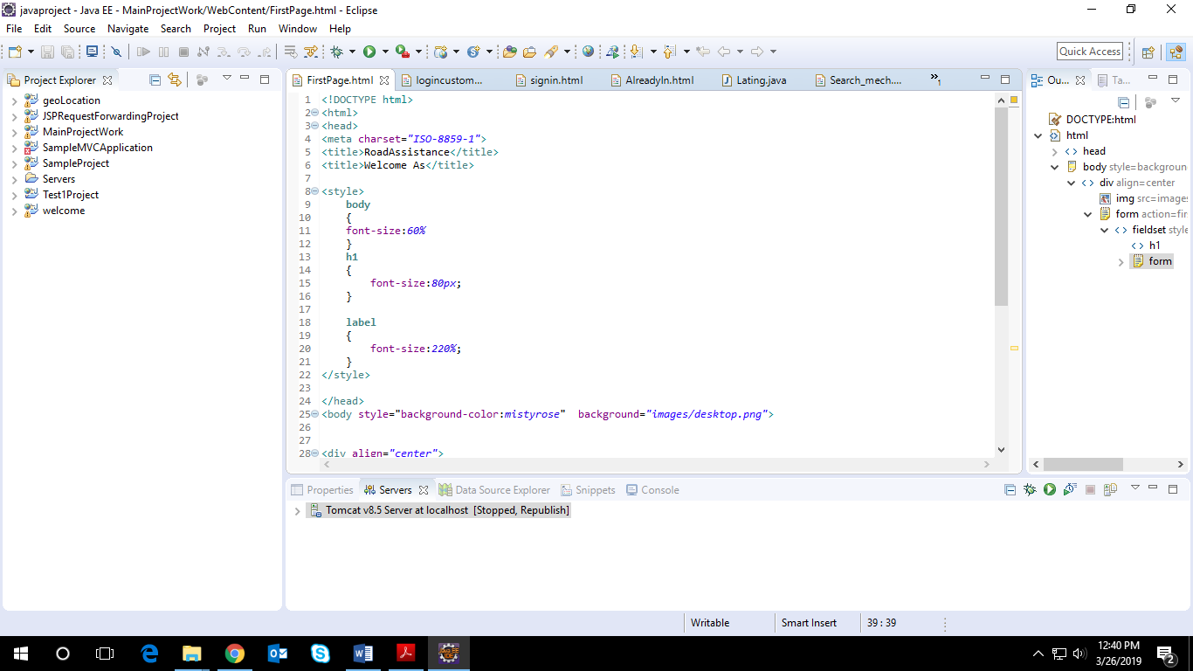

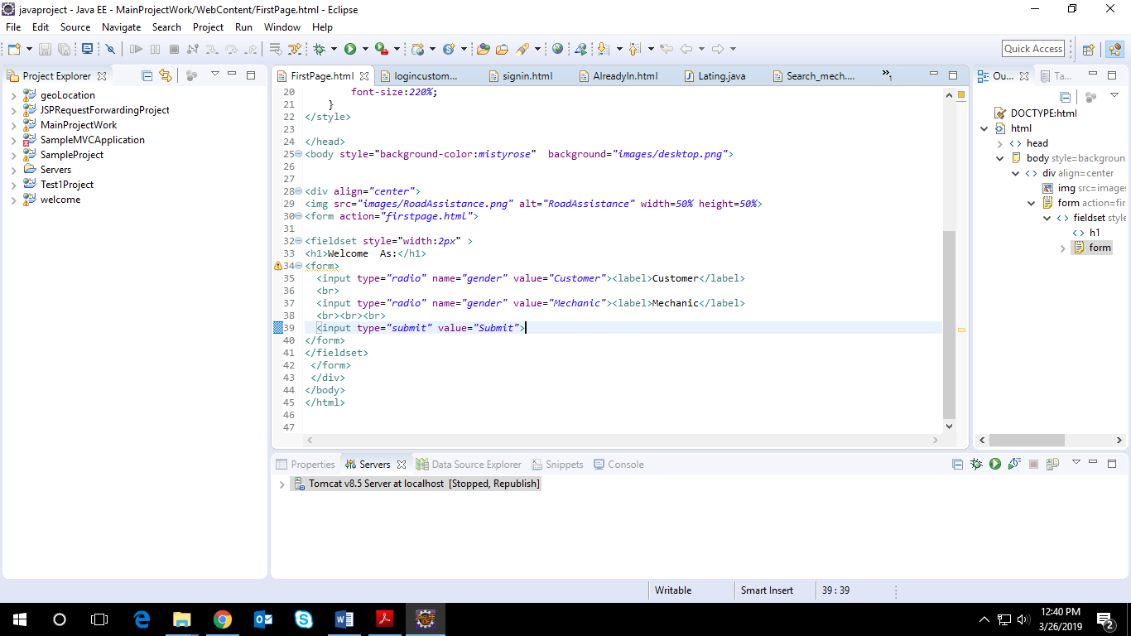

CODES REQUIRED FOR MIDDLEWARE

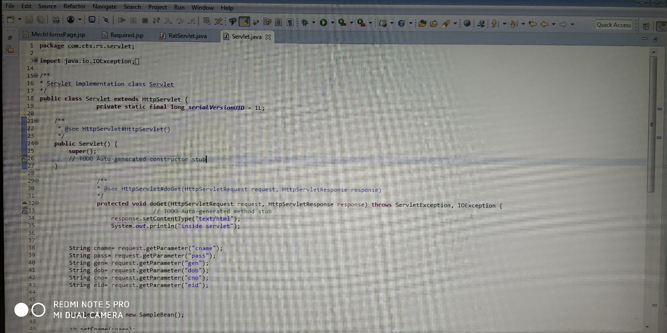

CODES FOR BACKEND

